Ex.no:3 | DATA CLEANING

Aim:

Algorithm:
Check Missing Values:
- Start.
- Import the pandas library.
- Load the dataset into a DataFrame (df).
- Display dataset information using df.info().
- Check missing values using df.isnull().
- Count missing values using df.isnull().sum().
- Check missing values using df.isna().
- Check non-missing values using df.notnull().
- Display the results.

Drop Missing Values
- Start.
- Import the pandas library.
- Load the dataset into a DataFrame (df).
- Drop missing rows using dropna().
- Drop rows (axis=0) or columns (axis=1).
- Use how='any' to remove rows/columns containing any missing value.
- Use how='all' to remove rows/columns only if all values are missing.
- Use thresh=N to keep rows/columns with at least N non-missing values.
- Use subset=['column_name'] to drop rows based on specific columns.
- Use inplace=True to modify the original DataFrame.
- Display the cleaned DataFrame.

Program:
import pandas as pd

# Load dataset

df = pd.read_csv("KaggleV2-May-2016.csv")

print("===== DATASET INFO =====")

df.info()

print("\n===== MISSING VALUES IN EACH COLUMN =====")

print(df.isnull().sum())

print("\n===== TOTAL MISSING VALUES =====")

print(df.isnull().sum().sum())

print("\n===== ANY MISSING VALUES? =====")

print(df.isnull().values.any())

print("\n===== NON-MISSING VALUES COUNT =====")

print(df.notnull().sum())

import pandas as pd

df = pd.read_csv("KaggleV2-May-2016.csv")

# Fill all missing values with 0

df_constant = df.fillna(0)

print("===== CONSTANT VALUE =====")

print(df_constant.head())

# Fill 'Age' column with mean

df_mean = df.copy()

df_mean["Age"] = df_mean["Age"].fillna(
df_mean["Age"].mean()
)

print("\n===== MEAN =====")

print(df_mean.head())

# Fill 'Age' column with median

df_median = df.copy()

df_median["Age"] = df_median["Age"].fillna(
df_median["Age"].median()
)

print("\n===== MEDIAN =====")

print(df_median.head())

# Fill 'Neighbourhood' column with mode

df_mode = df.copy()

df_mode["Neighbourhood"] = df_mode["Neighbourhood"].fillna(
df_mode["Neighbourhood"].mode()[0]
)

print("\n===== MODE =====")

print(df_mode.head())

# Forward Fill

df_ffill = df.ffill()

print("\n===== FORWARD FILL =====")

print(df_ffill.head())

# Backward Fill

df_bfill = df.bfill()

print("\n===== BACKWARD FILL =====")

print(df_bfill.head())

import pandas as pd

df = pd.read_csv("KaggleV2-May-2016.csv")

# Drop rows with missing values

df_drop_rows = df.dropna()

print("===== DROP ROWS =====")

print(df_drop_rows.head())

# Drop columns with missing values

df_drop_cols = df.dropna(axis=1)

print("\n===== DROP COLUMNS =====")

print(df_drop_cols.head())

# Drop rows having any missing value

df_any = df.dropna(how="any")

print("\n===== DROP HOW='ANY' =====")

print(df_any.head())

# Drop rows where all values are missing

df_all = df.dropna(how="all")

print("\n===== DROP HOW='ALL' =====")

print(df_all.head())

# Keep rows with at least 10 non-null values
# (12 columns total)

df_thresh = df.dropna(thresh=10)

print("\n===== THRESH=10 =====")

print(df_thresh.head())

# Drop rows where 'Gender' or 'Age' is missing

df_subset = df.dropna(
subset=["Gender", "Age"]
)

print("\n===== SUBSET (Gender, Age) =====")

print(df_subset.head())

# Drop missing values permanently

df.dropna(inplace=True)

print("\n===== AFTER inplace=True =====")

print(df.head())

Output:

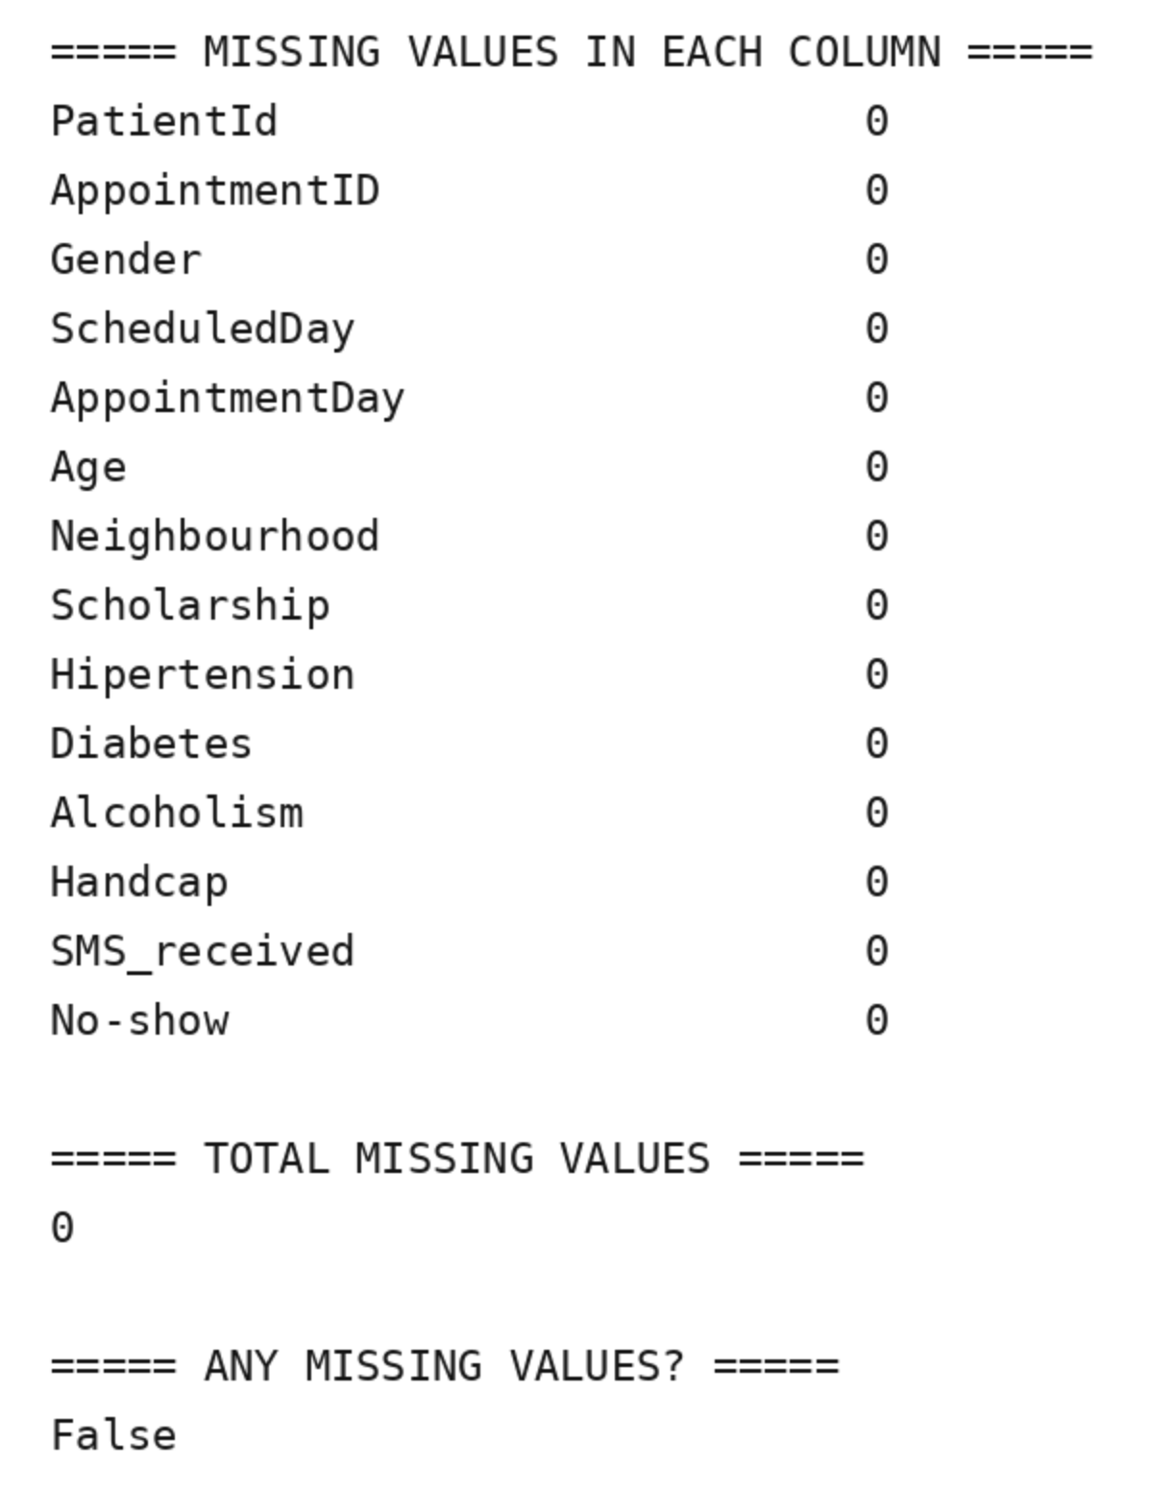

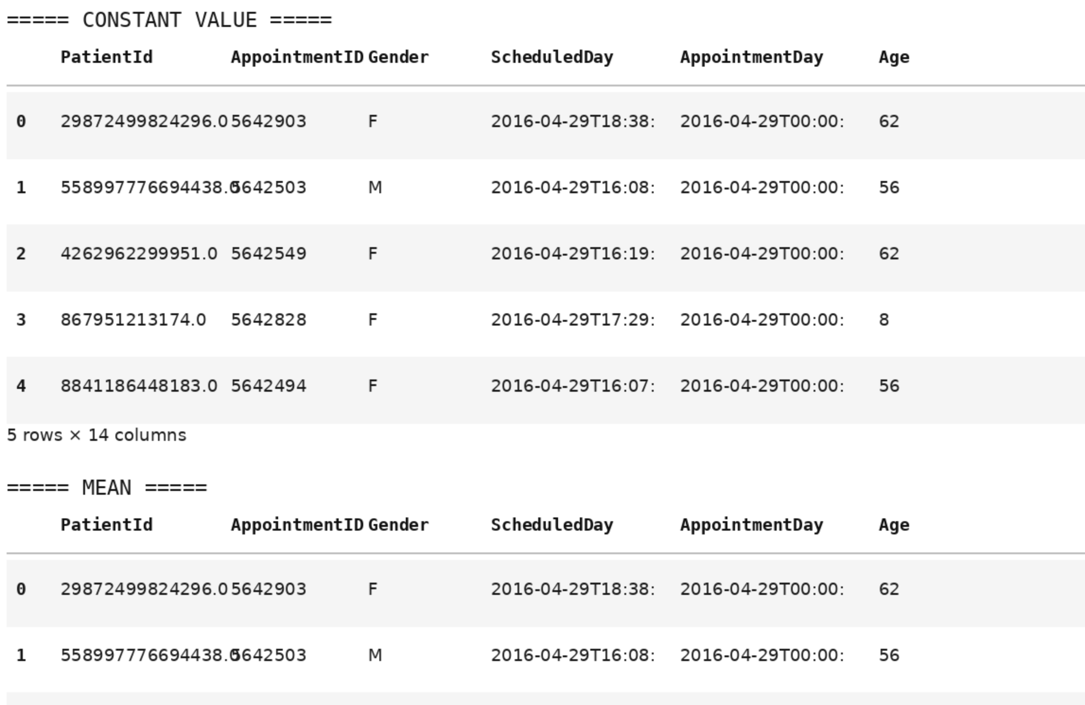

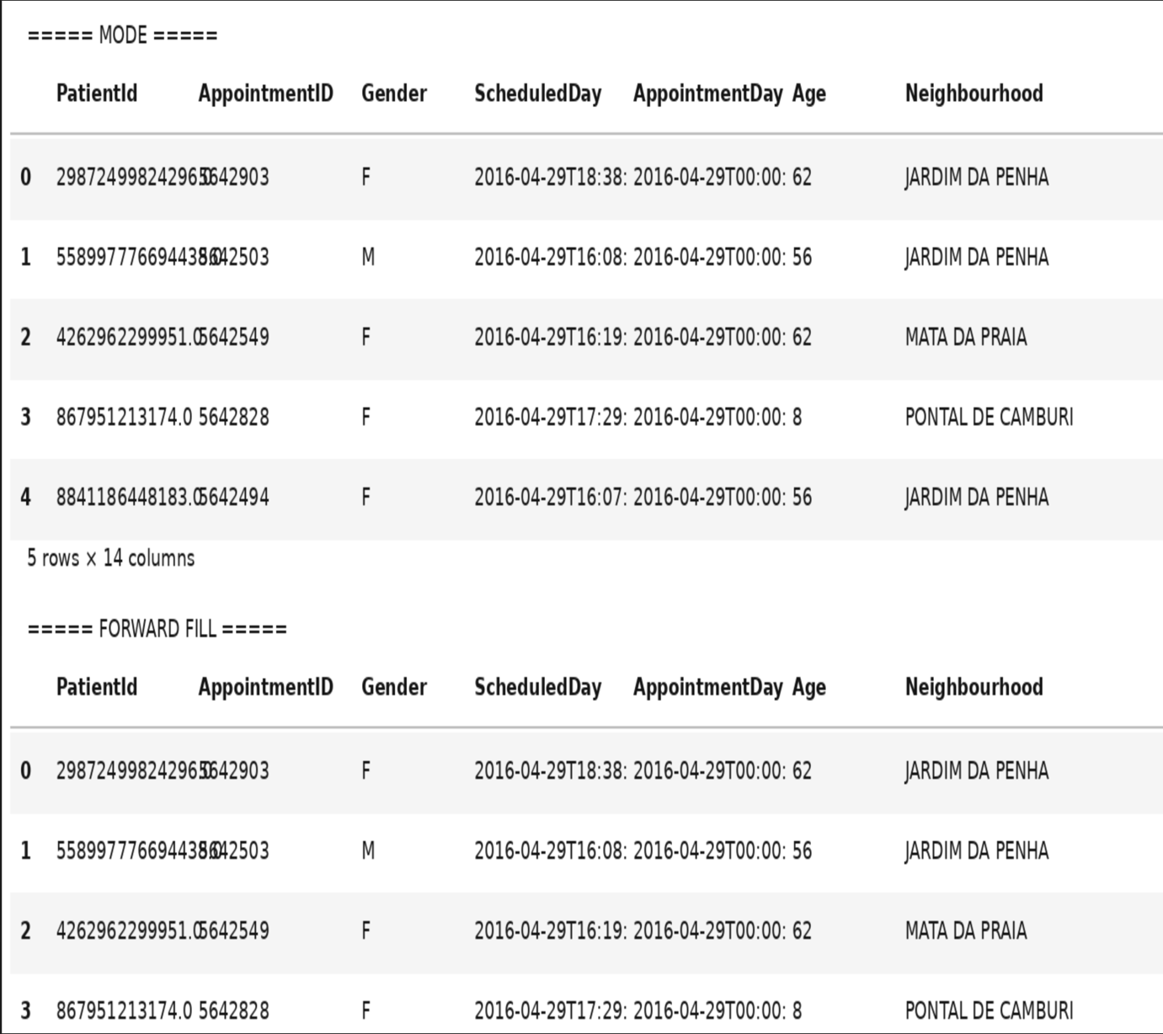

Result:

